Title: Program to Implement Linear and Binary Search.
Problem Statement:
Write menu based program
a) Write a program to store roll numbers of student in array who attended a training program in random order. Write a function for searching whether a particular student attended a training program or not, using Linear search.
b) Write a program to store roll numbers of student array who attended training programs in sorted order. Write a function for searching whether a particular student attended a training program or not, using Binary search.
Outcomes
- Students will be able to write programs for searching data in arrays.
- Understand the working and efficiency of linear and binary search algorithms.

Software & Hardware Requirements
Requirement | Specification
Programming Language | C++ / C
Compiler | GCC / G++
Hardware | i3 or above, 4 GB RAM or more
OS | Windows/Linux

Theory :
Linear Search: A sequential search where each element is checked one by one until the desired element is found.
Linear Search Algorithm
- Start
- Input array elements and target value
- Traverse the array from index 0 to n-1
- If element matches target, return FOUND
- Else continue
- If not found, return NOT FOUND
- Stop

Flow Chart for Linear Search:
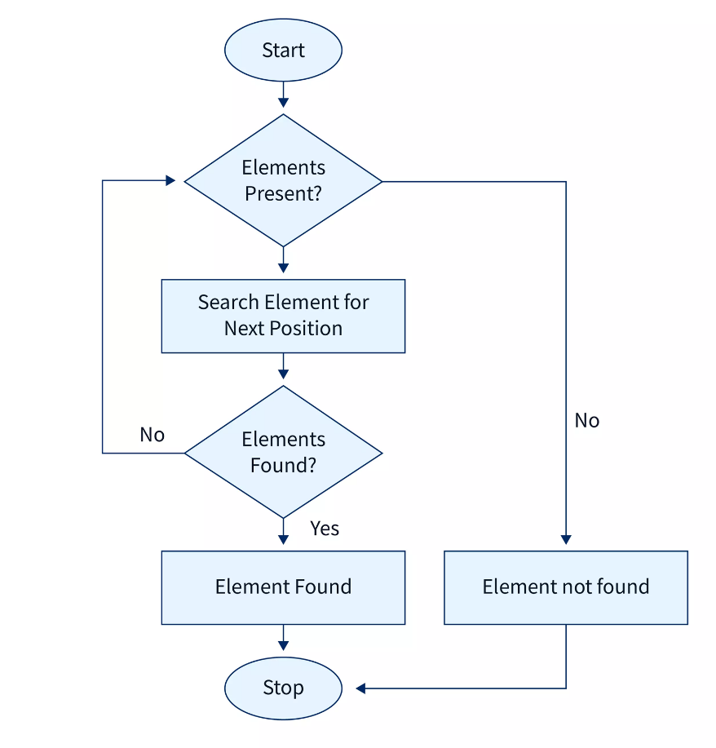

Binary Search: A divide-and-conquer approach which requires the data to be sorted. It reduces the search space in half each time.
Binary Search Algorithm
- Start
- Input sorted array and key value
- Set low = 0 and high = n - 1
- While low ≤ high:
  - Compute mid = (low + high) / 2
  - If array[mid] == key, return FOUND
  - Else if key < array[mid], set high = mid - 1
  - Else set low = mid + 1
- If loop exits, return NOT FOUND
- Stop

Flow Chart for Binary Search:
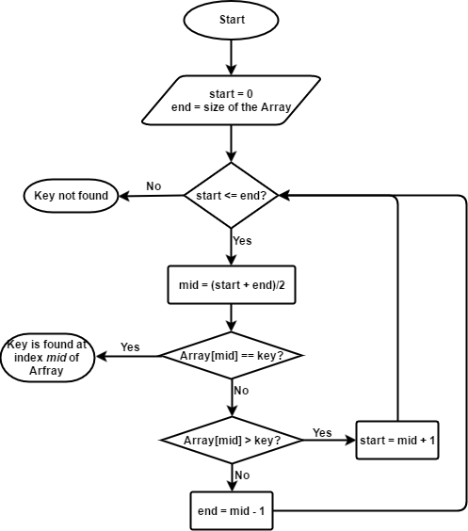

Mathematical Model (If applicable)
Let:
- S = {s1, s2, s3, ..., sn} be the set of roll numbers
- P = search(S, key) is the process of checking membership
- f(P) = {found, not found}
Input: Roll numbers S, Search key
Output: f(P) indicates presence or absence of roll number

Conclusion
- Linear search is simple but inefficient for large datasets (Time Complexity: O(n)).
- Binary search is faster (Time Complexity: O(log n)) but requires sorted input.
- Both techniques are foundational for understanding advanced searching and sorting algorithms.

